Cinema Tickets Booking Website

Dev Kapadia  
*Information Technology*  
*C S Patel Institute of Technology, CHARUSAT*  
Changa, India  
20it050@charusat.edu.in

Rency Kapadia   
*Information Technology*  
*C S Patel Institute of Technology, CHARUSAT*  
Changa, India  
[20it051@charusat.edu.in](mailto:20it051@charusat.edu.in)

Rekha Karanjiya   
*Information Technology*  
*C S Patel Institute of Technology, CHARUSAT*Changa, India  
[rekhakaranjiya.ce@charusat.ac.in](mailto:rekhakaranjiya.ce@charusat.ac.in)

*Abstract*—In 21 centuries, all work is doing digitally and fast. Face recognition system can significant role in attendance system. In this paper we have proposed the application called FRAS based on the similar concept. Using this application, attendance can be taken extremely fast and smarter way. The proposed application can be used mostly in classroom, office, and collages. FRAS is an image processing application. Firstly, system find faces and recognize them. It checks that photo in present in the database, if that photo precents in data base than it will mark present otherwise it will mark absent. This system is amazingly simple and secure method of taking attendance. The main purpose of this device is to be an efficient and taking attendance in classroom without any time consumption and physical work. Main advantage of this system is less cost and need less installation.

Keywords—Face Recognition, Attendance System, Image Processing

# Introduction (*Heading 1*)

Identification and detection of human face using an application became an important part of software automation and information security. The Face Recognition based Attendance System (FRAS) is a part of biometric identification.

This system detect unique points in person faces. This technology is much more effective than biometric based recognition techniques like finger-print, palm-print, iris because of its non-contact process.

The face recognition techniques are currently used in social media websites like Facebook, at the airports, railway stations. At crime investigations, Face recognition technique can also be applied in crime reports, the captured photo can be stored in a database, and can be used to find a person. In Instagram and

Facebook use facial recognition technique for automatically tag people. [1]. A Face Recognition Attendance System is a system by which we can take attendance easily and that class teacher or faculty of their school or college do not have to do challenging work for attendance, Because

now adays, attendance is taking in attendance sheet and then teacher mark attendance in their computer and sometimes mistakes are occurring. Sometime, there are some chances of proxy attendances. So, it is exceptionally lengthy process so for do not getting any mistakes and to save our time we can use Face Recognition attendance System.

In this system it will find faces, detect them, and check that detected faces in database (saved photos) and if it is there then it marks an attendance.

There are 5 steps to identification the face.[2].

1. Firstly, focus on the picture and find all the faces
2. Second, focus on every face and try to understand that if a face is in weird direction or in bad lighting, it is still the same person.
3. Third, pick out unique features of the face –like hoe big eyes are, how long the face is, etc.
4. Forth, compare the unique features of face and figure out the person’s name.
5. Finally, all taken attendance name are store in excel sheet.

# Working if the syste

## Face Detection

Face detection is a particularly good feature in cameras. when we open camera than they are automatically pick out faces and check it all faces are in focus before takes the pictures. We take every single pixel in us at a time. We are trying to figure out how the current pixel is compared to the pixels directly surrounding it. We draw an arrow to show direction the image is getting darker. Repeat this process every single pixel in images. In end, every pixel replaced by an arrow.

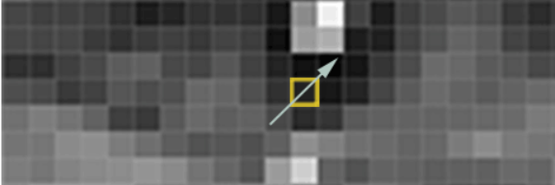

1. Pixel comparision.

Theses arrows are called gradients We will break the images in small squares of 16x16 pixels each. We try to solve this thing using python and dlib.

## Poising and Projecting of faces

In first part we find all the faces but what if our face is in weird or bad direction? So, our second step aim is to understand face in weird direction and still it is the same person.

To solve this problem, we will try to wrap each face using an algorithm called FACE LANDMARK ESTIMATION. In this algorithm, we must specify points in a different position on our faces – like the top of the chin, outside edge of each eye, the inner edge of each eyebrow etc. So, as we told above, we will specify 68 specific points (Landmark) which is wrap all that specified position of face.

How we can specify that 68 points are shown below.

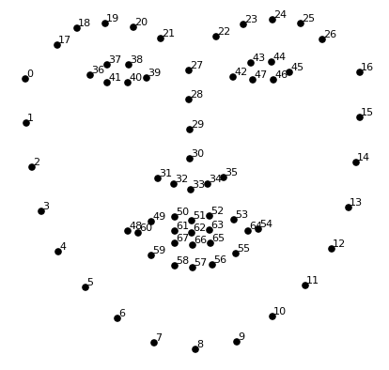

1. Face Landmark (Specified points).

And the result of that specifying 68 face landmarks on our test image:

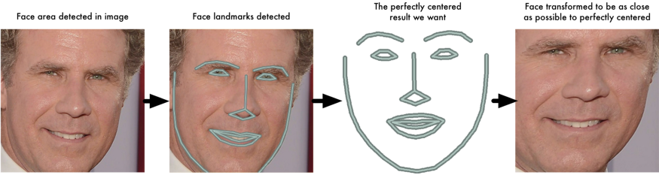

1. Example of a figure caption. (*figure caption*)

So, here is no matter how the face is turned, we can centre the eyes and mouth are in the same position in image.

## Recognize the Face

Identify applicable funding agency here. If none, delete this text box.

The template is used to format your paper and style the text. All margins, column widths, line spaces, and text fonts are prescribed; please do not alter them. You may note peculiarities. For example, the head margin in this template measures proportionately more than is customary. This measurement and others are deliberate, using specifications that anticipate your paper as one part of the entire proceedings, and not as an independent document. Please do not revise any of the current designations.

Simplest way to face recognize is directly compare the photo with unknown person. In large scale, we have lot of pictures so hard to compare them.

Its solution is we take measurement from each face. In same way, we also take measurement our unknown face. In last we compare that measurement and find the known face with the closest measurement like measure the size of each ear, space between eyes, length of nose, etc.

We upload three types of images for recognized faces.

1. Upload a training face images of a known person.
2. Upload another picture of the same known person.
3. Upload different person picture.

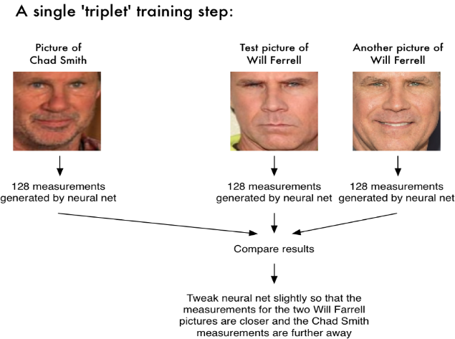

1. Example of a figure caption. (*figure caption*)

We take 128 measurements of each face for find the certain person. This measurement helps us for exact face recognize.

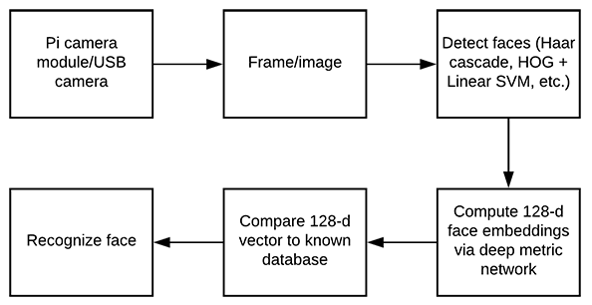

1. Process to take 128 measurment

So far, we have seen how to find all that faces and projecting of faces and how to recognize faces but here is one question that how to identify that faces? How to know who is in this picture?

So, for that we can link their login information to the system. In this what will do that first system detect the face then match it with that login information which is already saved in the database and according to that it will find a name and ID of that particular person.

Then if that face will match then attendance will be taken automatically.

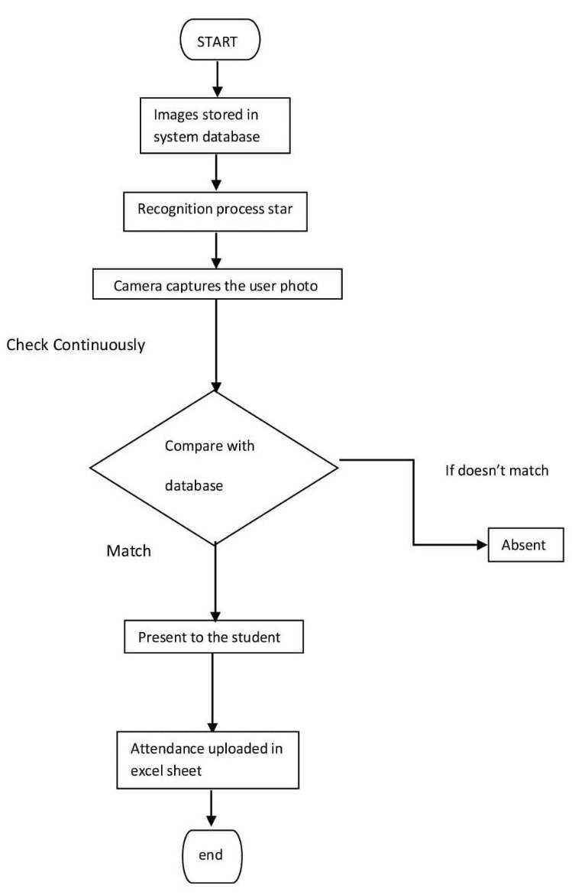

1. Process of FRAS.

# advantages

1. This software can handle giant database and store substantial number of images.
2. Accuracy of this algorithm is more than other algorithms.
3. 3. This system does not require network connectivity so there is no any issue of network related       problems.
4. Time consumption of recognise face and creating database is very less.
5. We reduce many errors and increase accuracy because human and machine interface is less.
6. The system is easy to use and easy to use with great accuracy while having student attendance.
7. For multiple faces also the system works correctly and attendance successfully updated.
8. The image capture speed is also good that takes images without being struck.

# conclusion

Fundamentally, this system work for amending attendance system in every domain like schools, colleges, organizations, institutions, and companies. Capturing live images from camera and application of different facial detection techniques and deal with appetite which will shorten manual or traditional job. In our solution, by engendering interface

we engender the dataset. We trained the images utilizing Har Cascade and AdaBoost classifier. It will successfully detect and identify faces and non-faces after training. When the stored and compared photos match, the attendance sheet is automatically updated with the time and date. It is easier for faculty members to keep track of student time because it stores the entrance time of each student.

##### References

1. Neha Kumari Dubey , Pooja M. R. , K Vishal , Dhanush Gowda H. L, Keertiraj B. [Volume 09, Issue 06 (June 2020)](https://www.ijert.org/volume-09-issue-06-june-2020%20?)
2. Adam Geitgey , Machine learning is fun!,part-4:modern face recognition with deep https://medium.com/@ageitgey/machine-learning-is-fun-part-4-modern-face-recognition-with-deep-learning-c3cffc121d78
3. Bramer, Max (2006). Artificial Intelligence in Theory and Practice: IFIP 19th World Computer Congress, TC 12: IFIP AI 2006 Stream, August 21–24, 2006, Santiago, Chile. Berlin: Springer Science+Business Media. p. 395. [ISBN](https://en.wikipedia.org/wiki/ISBN_(identifier)) [9780387346540](https://en.wikipedia.org/wiki/Special:BookSources/9780387346540).
4. Office, U. S. Government Accountability. ["Facial Recognition Technology: Federal Law Enforcement Agencies Should Have Better Awareness of Systems Used By Employees"](https://www.gao.gov/products/gao-21-105309). www.gao.gov. Retrieved September 5, 2021.
5. [Jump up to:a](https://en.wikipedia.org/wiki/Facial_recognition_system#cite_ref-:10_4-0) [b](https://en.wikipedia.org/wiki/Facial_recognition_system#cite_ref-:10_4-1) Staff, By GCN; Jun 10, 2020. ["IBM bows out of facial recognition market -"](https://gcn.com/articles/2020/06/10/ibm-quits-facial-recognition.aspx). GCN. Retrieved October 7, 2021.
6. Nilsson, Nils J. (2009). The Quest for Artificial Intelligence. Cambridge University Press. [ISBN](https://en.wikipedia.org/wiki/ISBN_(identifier)) [9781139642828](https://en.wikipedia.org/wiki/Special:BookSources/9781139642828).
7. de Leeuw, Karl; Bergstra, Jan (2007). The History of Information Security: A Comprehensive Handbook. Elsevier. p. 266. [ISBN](https://en.wikipedia.org/wiki/ISBN_(identifier)) [9780444516084](https://en.wikipedia.org/wiki/Special:BookSources/9780444516084).
8. Gates, Kelly (2011). Our Biometric Future: Facial Recognition Technology and the Culture of Surveillance. NYU Press. pp. 48–49. [ISBN](https://en.wikipedia.org/wiki/ISBN_(identifier)) [9780814732090](https://en.wikipedia.org/wiki/Special:BookSources/9780814732090).
9. Gates, Kelly (2011). Our Biometric Future: Facial Recognition Technology and the Culture of Surveillance. NYU Press. pp. 49–50. [ISBN](https://en.wikipedia.org/wiki/ISBN_(identifier)) [9780814732090](https://en.wikipedia.org/wiki/Special:BookSources/9780814732090).
10. Gates, Kelly (2011). Our Biometric Future: Facial Recognition Technology and the Culture of Surveillance. NYU Press. p. 52. [ISBN](https://en.wikipedia.org/wiki/ISBN_(identifier)) [9780814732090](https://en.wikipedia.org/wiki/Special:BookSources/9780814732090).
11. Gates, Kelly (2011). Our Biometric Future: Facial Recognition Technology and the Culture of Surveillance. NYU Press. p. 53. [ISBN](https://en.wikipedia.org/wiki/ISBN_(identifier)) [9780814732090](https://en.wikipedia.org/wiki/Special:BookSources/9780814732090).